Partner Discussion Question

Think about the demonstration you just saw. Compare lost/unsaved people to unreached people? How are they the same? How are they different?

State of the World Today

What is the world population? ______ billion

10 people that represent the world:

Person 1 (both hands crossed over heart): ___________________
Persons 2 and 3 (one hand crossed over heart): ______________
Persons 4, 5, 6 (push hands out in front as if rejecting): ________________
Persons 7, 8, 9, 10 (hands over ears): _____________

What fraction of the world has never heard the gospel message? ______

Nation (ethne): Country vs. People Group

Jesus commanded us to make disciples of all nations. (Matthew 28:19-20)

A nation is not a ________________, but an ethnic group. (Revelation 7:9)

A people group is an ethnic group that shares the same _____________________________________________________________________

_____________________________________________________________________

The same country can have many different people groups. For example, India is one country with more that 2,500 people groups [i].

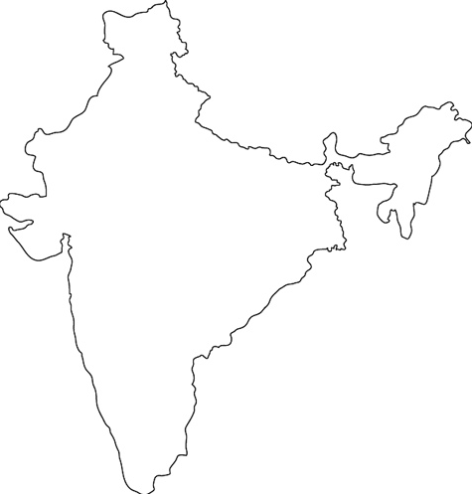 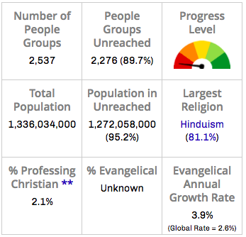 [i]

Reached vs. Unreached

- Bible: ______________________________________________
- Phone or iPod: _______________________________________
- Church: _____________________________________________
- Mirror: ______________________________________________
The difference between a reached and unreached person is their access to the gospel, not their willingness to believe.

To obey Jesus’ command to “make disciples of all nations,” we will need to go where the unreached peoples are.

What God’s Word Says About Unreached Peoples

John 3:16

John 14:6

Revelation 7:9

Pray in Kid-Friendly Ways

Hang a world map in your home or classroom and let it be central to your prayer times.

For younger children:
- Focus on continents or countries of the world where many unreached people live.
- Choose a different country each month.
- Focus on a different aspect of culture or spiritual needs each week.
- Engage children’s five senses or use concrete objects and actions to help them pray for others.
For older children:
- Focus on world religions, specific unreached peoples, and global workers.
- Introduce different religious beliefs and practices by comparing them to what God’s Word says.
- Pray for global issues and current events.
- Keep your prayer times short and active.

Beliefs of Unreached Peoples

Animist

Hindu

Atheist

Muslim

Buddhist

Our Part

Today there are about 7,000 unreached people groups. Back in 1990, there were 12,000 unreached people groups.^{[ii]}
In the past 25 years, the number of unreached people groups has been cut in half.

Think about the next 25 years. It is likely that our children may be part of the generation of believers who reaches the remaining people groups with the gospel.

What does the decreasing number of unreached people groups mean for our generation of children?

In missions today, God is using the entire global church! Almost half of the world’s largest missionary sending countries today are located in places other than North America and Europe – countries like Brazil, India, South Korea, Nigeria, and South Africa.^{[i]}

African, Asian, and Latin American children will play a huge role in finishing the task of reaching the unreached around them.

What does the increasing role of Christians in Africa, Asia, and Latin America mean for our generation of children?

Are our children prepared to embrace the task? Do they have a heart to reach the unreached?

“If tomorrow’s world of unreached people were waiting for MY kids,
would MY kids have a heart to reach them based on what I am giving them?"

Rescue Activity and Prayer

God desires to rescue unreached peoples from darkness and bring them into the kingdom of His Son (Colossians 1:13-14).

Our children are part of the generation of believers who will do this.

- Pray for the unreached people group on your prayer card.
- Pray for the children you are raising and discipling. Pray that they would reflect God’s heart and purposes.

[i] Joshua Project (joshuaproject.net).
[ii] Frontier Ventures (frontierventures.org).

